**Ex 4 – 5 : Practicing DDL Commands (Data Definition Language)**

**• Create table command**

**• Alter table command**

**• Truncate table command**

**• Drop table command**

CREATE SCHEMA `employee` ;

DESC `employee`.`emp_table`;

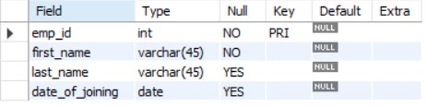

C:\Users\thanm\OneDrive\Desktop\dbms lab\exp 4 and 5\2.PNG

DROP TABLE `employee`.`emp_table`;

CREATE TABLE `employee`.`emp_table`

(

`emp_id` INT NOT NULL,

`first_name` VARCHAR(45) NOT NULL,

`last_name` VARCHAR(45),

`date_of_joining` DATE,

PRIMARY KEY (`emp_id`)

);

ALTER TABLE `employee`.`emp_table`

ADD email varchar(20);

TRUNCATE TABLE `employee`.`emp_table`;

